Dynagage Summary

Measuring sap flow is like finding the weight of your shoes by subtracting your barefoot weight from your shoes-on weight.

To measure sap flow (**f**), we first measure the heat carried by the moving sap (**Qf**).

Qf is the remainder once the axial and radial heat fluxes (**Qv** & **Qr**) are subtracted from the power input (**Pin**).

**Qf = Pin – Qr – Qv**

*The examples use values from Duckhorn_3 Palms_5_V2_sensor size 25*

*7/29 at 3:45 PM, High flow status*

|  |  |  |  |  |  |  |  |  |  |
| --- | --- | --- | --- | --- | --- | --- | --- | --- | --- |
| **Pin** | **Qv** | **Qr** | **Qf** | **dT** | **dx** | **A** | **R** | **Ksh** | **Kst** |
| 0.523  deg C | 0.0309 deg C | 0.1022  deg C | 0.3902 deg C | 0.463  deg C | 7mm | 5.89m^2 | 41.3 ohms | 4.648  W/mV | 0.42  W/mK |

|  |  |  |  |
| --- | --- | --- | --- |
| **Vin** | **AH** | **BH** | **CH** |
| 4.65 V | 0.001mV | 0.036mV | 0.022mV |

1. **Pin** is the power input.

**Pin=** Voltage^2/R

.523 = (4.65)^2/41.3

.523=.523

1. 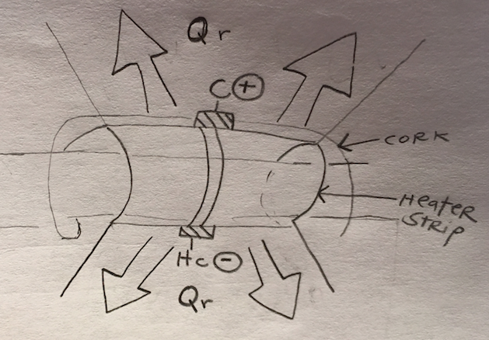**Qr** is radial heat conducted through the stem to the ambient. It is the product of the conductivity of the sheath (**Ksh**) multiplied by the thermopile output, **CH** (C-Hc).

**Qr =** Ksh*CH

0.1022 =4.648*0.22

0.1022=0.1022

*\*Conductivity is the rate at which heat flows through a material. For example, the conductivity of the sheath (4.648) is greater than the conductivity of an insulator like fiberglass (0.045).*

1. 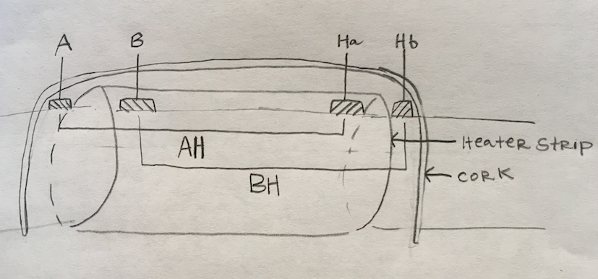**dT** aka ∆T = is the change in temperature between thermocouple junctions. It is the average of AH (A-Ha) and BH (B-Hb), converted from mV to Celsius.

**dT**=(AH + BH)/2

0.463 =(.001+.036)/2

0.463 =0.074(c/.o4mV)

0.463=0.4625 deg C

1. 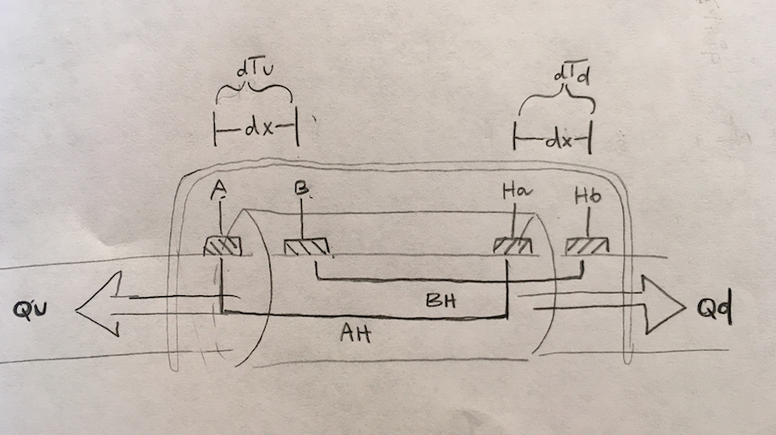Now that we know dT, we can find Qv. **Qv** is the sum of the axial heat conducted through the stem, upstream (**Qu**) and downstream (**Qd**) of the sensor. The sum is automatically computed (and we don’t know dTu or dTd), but it helps to think of the equations separately. Multiply the conductivity of the stem (**Kst**) and the area of the stem cross-section (**A**). Then, multiply that product by the change in temperature between the thermocouple junctions (**dT**) divided by the distance between the thermocouple junctions (**dx**). Convert to Celsius.

**Qv**= **Qu** + **Qd**

**Qu**= Kst*A*(dTu/dx)

**Qd**= Kst*A*(dTd/dx)

**Qv**= Kst*A*((BH-AH)/dx)

0.0309=(.042*.0589) * ((.036-.001)/.007)

0.0309=.024738 * 5 * (c/.04mV)

0.0309=0.0309

1. Now we can find **Qf**, the heat convection of the sap.

**Qf=** Pin – Qr - Qv

.3902 = 0.523-.1022-.0309

.3902=.3899

1. To find the flow rate per unit of time (**f**) divide the heat carried by the sap (**Qf**) by the heat differential between the thermocouple junctions (**dT**). Because sap is 99% water, multiple by the heat capacity for water to find a flow rate of grams/second.

**f**=(Qf/dT)

**f**= .0309/.463

**f**= .0667(4.186 joules/gram-celsius)

**f**=.279g/s

I don’t know where/how this value appears on VMMS. It does not correspond with ‘plant flow’ or ‘flow’ values, so it may be that I’m not converting to the correct units or otherwise miscalculating.

Take-Aways

***Inverse Relationship between f & dT***

The greater the flow, the lower the heat differential (dT). Imagine you apply equal heat to 1 gallon of water & 5 gallons of water. After 10 minutes the temperature differential of the 5 gallons will be 1/5 that of the 1 gallon. At high flows the sap is traveling from pre to post heater quickly & in high volume, and so a smaller ‘percentage’ of the sap is heated. Therefore, the effect on the downstream heater strip is proportionately less than that of the sap moving slowly, at low flow. This is why a dT <.5 is a sign of overflow.

Example:

f=Qf/dT

f=1/2 > f=1/4

***Overflow***

Increasing sensor size can effectively troubleshoot overflow, not because it can accommodate a higher Pin and so supposedly heat the sap more, but because the distance is greater between the TC junctions, allowing for greater dT.

|  |  |  |  |  |
| --- | --- | --- | --- | --- |
| **SGEX 10** | **SGEX 13** | **SGEX 16** | **SGEX 19** | **SGEX 25** |
| dx = 4mm | dx = 4mm | dx = 5mm | dx = 5mm | dx = 7mm |

If new models of sensors could be designed to have the same diameter, but a longer heater strip or greater distance between TC junctions, it would help the problem of overflow.

***Inverse Relationship of f with Qv & Qr***

When there is less sap to carry the heat, more heat is lost to the ambient. Conversely, as flow increases, Qv and Qr decrease.

***AH & BH***

**BH–AH = (B–Hb) – (A-Ha) = (B-A) + (Ha-Hb)**

**AH = A - Ha**

During the day when there is flow, Ha will be lower than A as the unheated sap cools the temperature at the Ha TC (picture a fan blowing on a space heater) and so AH will be positive.

At night, it is possible that Ha is greater than A, making AH negative. The TC junction at Ha has the heat of the heater strip, and the low flow is not carrying much sap to heat A.

**BH = B - Hb**

Even at low flow, Hb should always be less than B because it is before the heater strip, whereas B is heated by it. This is why BH should never be negative.

In general, **BH > AH** because **B – Hb > A - Ha**

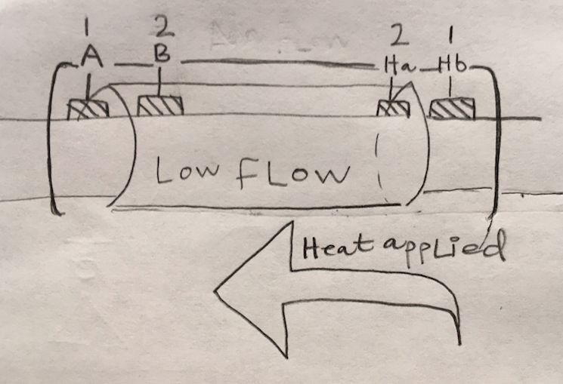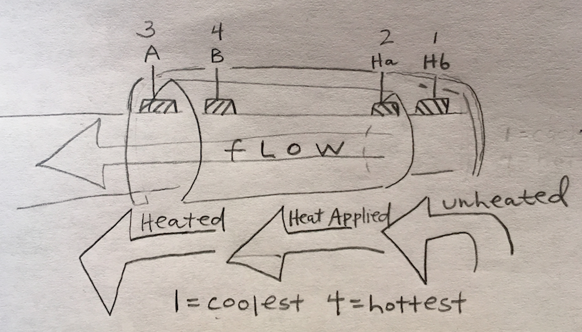

***Negative CH***

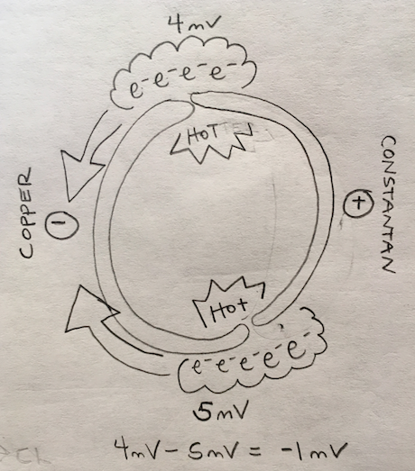CH is the thermopile (piles of thermocouples) output. A thermocouple is a pair of junctions, one of which is hotter than the other. The voltage at the 2 junctions will be different, by an amount dependent on their temperature differential. On hot days, it could be that there is not enough of a temperature differential between the two junctions, potentially leading to negative CH.

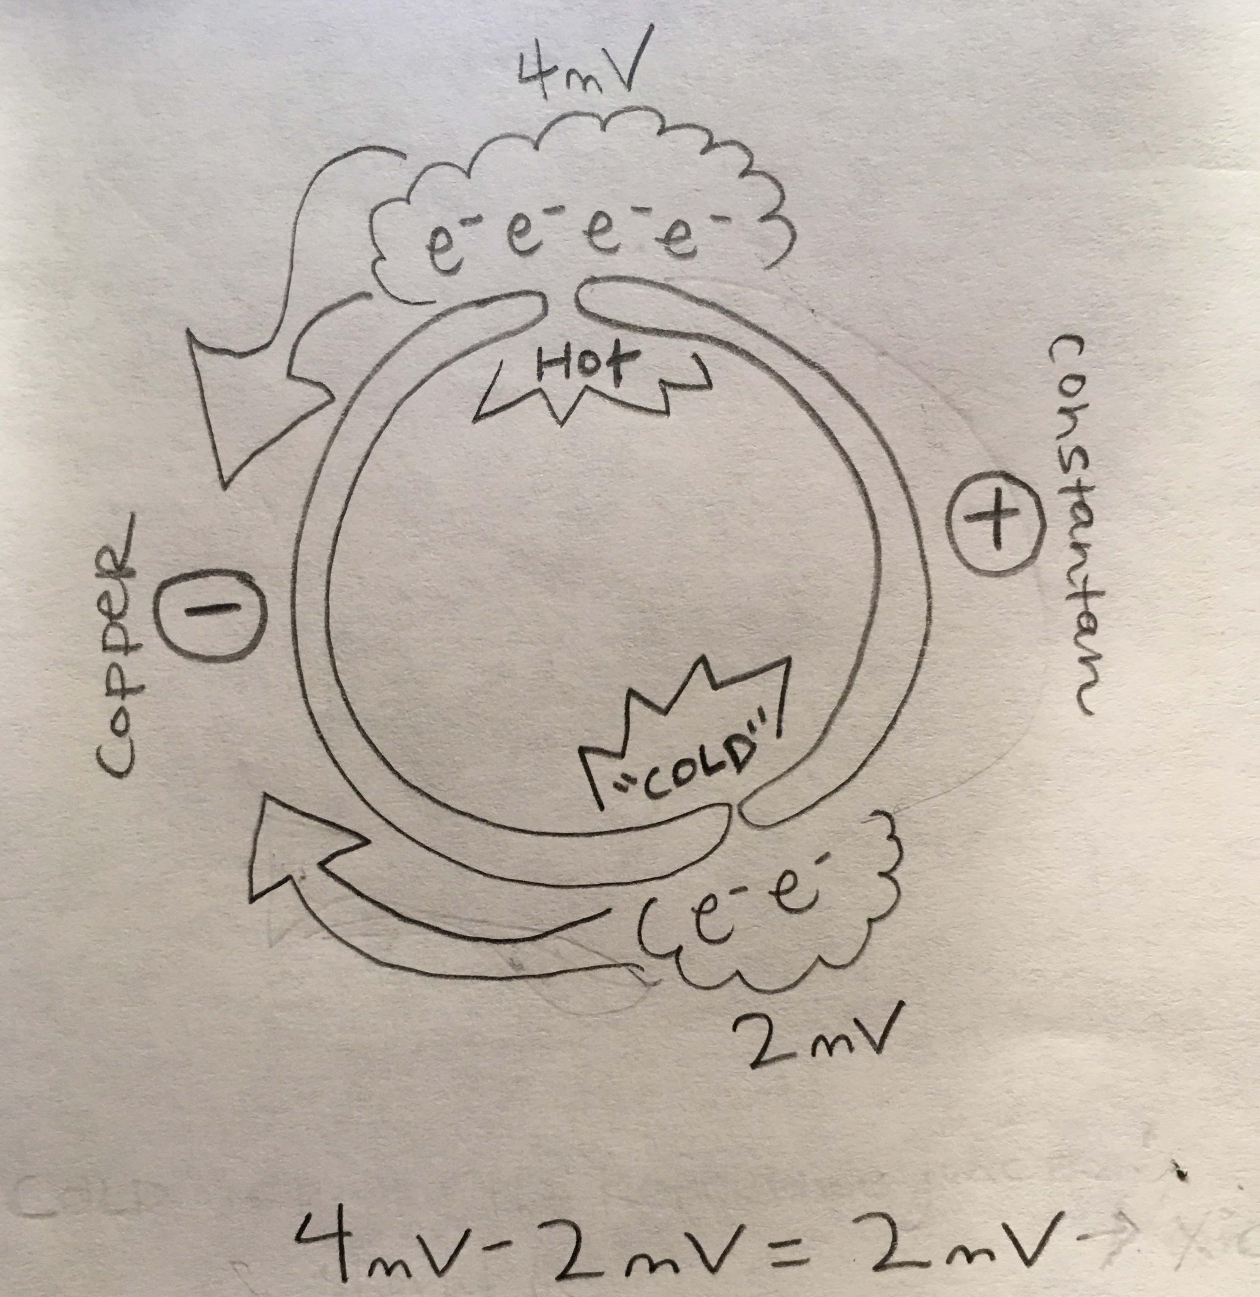

***Negative CH, Negative Qr & Pin***

Qf should not be >20% of Pin. According to Dynagage, these data points are filtered out as invalid as ‘flow errors may be very large’. If the heat carried by the sap (Qf) *is* >20% of Pin, it is possible that ambient heat is being included in the Qf calculation (eg. Qr and Qv are not being properly subtracted out of the equation). Looking through the data, it is clear that we have set a wider filter.

However, there were many instances where Qf > 100% of Pin. I picked 5 data points at random where Qf > Pin, and 1 data point that shows a ‘normal’ Qf, Pin relationship.

*All data points taken from **7/30/17** at **15:30 (~peak heat).**

|  |  |  |  |  |  |  |
| --- | --- | --- | --- | --- | --- | --- |
| **Vine** | **Flow Status** | **CH** | **Qr** | **Qf** | **Pin** | **Vin** |
| Harlan_Jeff_V1 | Normal | 0.071 | 0.925 | 0.2165 | 0.415 | 4.13 |
| Cakebread_ML_V2 | Normal | -0.035 | -0.1119 | 0.4803 | 0.43 | 4.30 |
| Screag_OldUpper_B_V2 | Normal | -.006 | -0.0142 | 0.3848 | 0.395 | 4.06 |
| RedEmp_Upper 4_V1 | Normal | -0.012 | -0.0275 | 0.4827 | 0.46 | 4.4 |
| SO_SodaCan_22_V1 | Normal | -0.014 | -0.0270 | 0.4070 | 0.40 | 4.11 |
| Ovid_1E_V1 | Normal | -0.015 | -0.0197 | 0.1468 | .127 | 4.30 |

At peak heat, CH becomes negative because there is no heat differential in the thermocouple. Because **Qr = Ksh * CH,** Qr will be negative when CH is negative. Negative Qr can account for Qf being greater than Pin.

Qf = Pin – Qr – Qv.

0.4803 = .430 – (-0.1119) - 0.0617

0.4803=.4802

*When CH is negative, Qr is negative so Qr is added to Pin, rather than subtracted.*

.4803 > .43 (Pin)

***Nighttime Values***

Nighttime values are significant in calibrating the conductivity of the sheath (**Ksh**). These values must be calculated when the sap flow is as close to 0 as possible so that only the heat of the heater strip, independent of the heat carried by the sap, is included in the calculation. Ksh accounts for the conductivity of cork and the dimensions of the sensor. Qr then accounts for these measurements to ensure that the heat of the sensor itself is not included in Qf. If nighttime values are invalid, as we often saw through 3.0, it could be affecting the calculation of Ksh, and by extension daytime values for Qr and Qf.

*\*Values from Colg_Josephine_V2, 7/20 at 21:30*

When Qf=0

Pin = Qr + Qv

Qr=Ksh(CH)=Pin - Qv

**Ksh =** (Pin- Qv)/(CH)

1.025= (.114-.0104)/.101

1.025=1.026

This value corresponds with the **Ksh_app**, which is > the **Ksh_in_use** value. I imagine there is another equation to correct for the approximation of Qf=0.

***Thermocouple Junctions & Thermopiles***

We use copper-constantan (Type T) thermocouples, which are ideal for differential measurements. There are 18 thermocouple junctions in the sensors, nine on each side of the heater strip, summed up in thermopiles (piles of thermocouples) so that the datalogger has larger values of mV to then convert to degrees Celsius. I think that the staple-like pieces we refer to as the thermocouples, are really thermojunctions, wired to multiple thermocouples. I’d like to learn more about the wiring and how it correlates with the pins in the harness/datalogger.

Big picture:

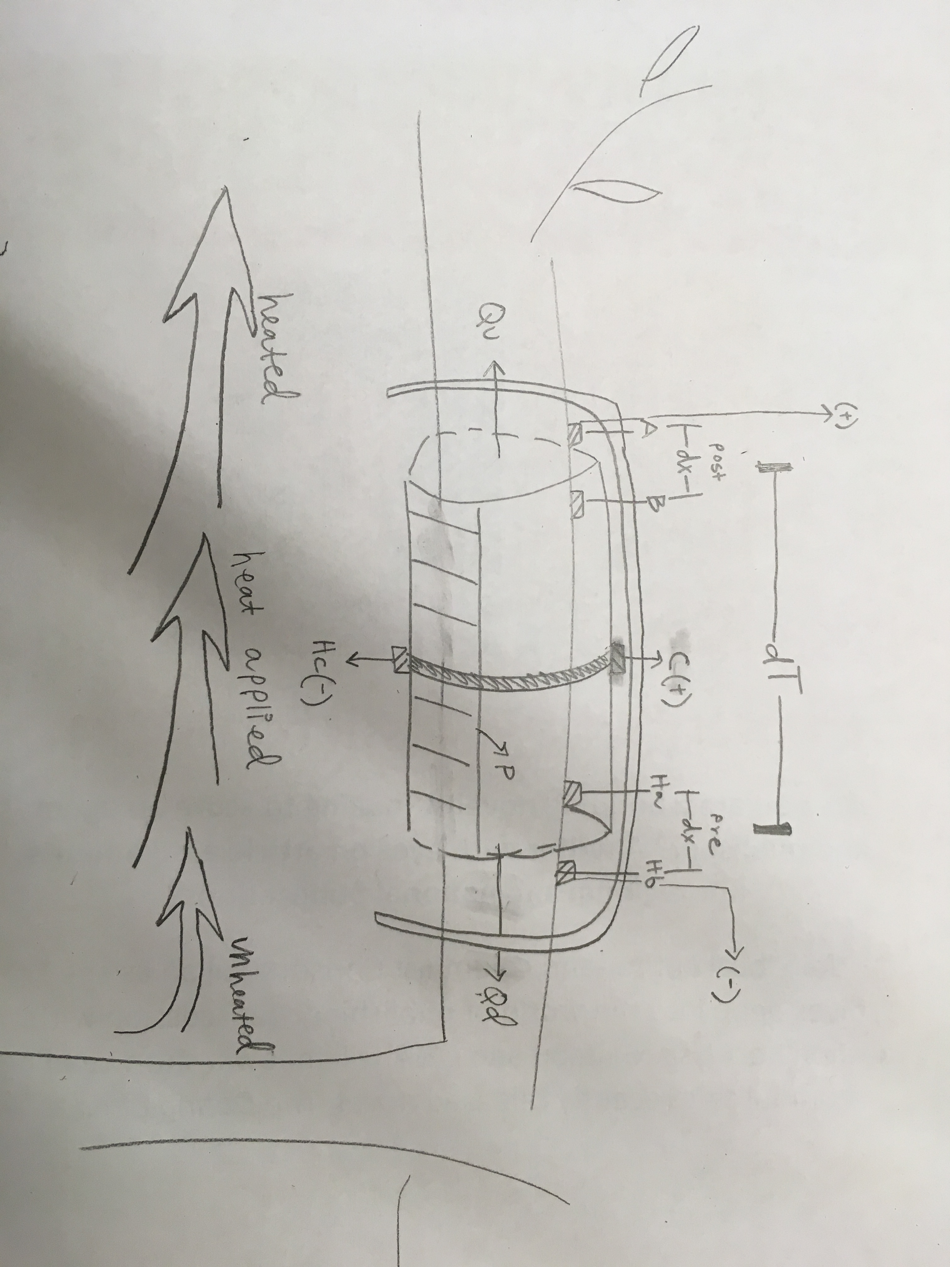

Chapter 2:

